  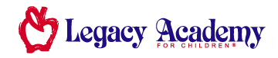  www.legacyacademy.com |  | Legacy Academy  515 E. Winmore Ave  Chapel Hill, NC 27516  919-929-7060  www.lachapelhill.com


Legacy Lines
A Newsletter for Families
March 2021

Why Reading with Children Is Important?

What You Need to Know:
Read with your baby and young child as often as you can, at least 10 minutes a day if possible. Even though your young child cannot read yet, listening as you read and looking at the pictures helps his brain develop and get ready for future school success. Reading stories is a great way to build vocabulary and foster a close emotional bond too. Keep books in the car, diaper bag, and at home so you are always ready when the time is right to read.

Benefits of Reading with Young Children

Learning to read may seem easy if you are a good reader, but it is a tough task for lots of children. It makes big demands on the brain and requires a young child to think differently. By reading aloud from birth or even before, you are building a solid foundation, book by book, that will help your child succeed in school and in life. Just as important, you will foster a love of reading for pure enjoyment. Books bring us experiences from people, places, and times that we could never have directly. They help us see things differently, learn important information, and expand our knowledge.

Basic Skills Your Child Will Learn from Reading with You
(1) How to hold a book and turn pages (2) Differences between words and pictures (3) New vocabulary words, (4) understanding rhyming words, (5) Different ways to think about common situations, handling all kinds of feelings (6) Names and sounds of alphabet letters (7) learning about story structure, such as beginning, middle, and end. (8) Making predictions about what may happen (9) seeing new possibilities (10) Making connections between the story and your child's life.

Take a Peek Inside .… | Let’s Celebrate
From the Desk of… 1  Framework for Their Future® ~ March 2  Enhanced Learning ~ March 3  Family Time: Read Across America 4  Family Time: Secret Letters 5 |   Daylight Saving  Sunday, March 14th  St. Patrick’s Day  Wednesday, March 17th  First Day of Spring  Saturday, March 20th  
1
Framework
For Their Future®

March Class Themes of the Month

 | Dreamers ~ Theme: Animal Babies  We will explore the exciting world of animals. Key experiences will include our delightful rhyme, Mary Had a Little Lamb. We will teach what baby animals say, and look at the differences in their appearance. With St. Patrick’s Day appearing this month, the dreamers will have a fun verse that goes along with it, sure to delight. With continued finger plays, sensory activities, and loads of love, your baby will have a great new month.
 | Travelers ~ Theme: E-I-E-I-O  Our toddlers will be milking a cow, making books, matching numbers and pictures, and so much more! Celebrating St. Patty’s day will present opportunities for interesting games, art projects, and a Shamrock Hunt. They will look for animals in books and learn the sounds each one makes. The nursery rhyme for March is “Little Boy Blue”, sure to bring a smile to their little faces. Not only do the children celebrate green, but they will play Pass the Shamrock!
 | Adventurers ~ Theme: Talk to the Animals  We will talk to, about, and with the animals in March. A week of Dinosaur days, a hunt for dino eggs, and making monkey bread. The Shamrock will delight your child while they learn the rhyme “Baa, Baa, Black Sheep”. These activities and key experiences will lend themselves well to usher in a new season.
 | Discoverers ~ Theme: Animal Friends  March brings with it a delightful new array of activities and learning experiences. Our little ones will learn the rhyme “Hey Diddle, Diddle”, among others. Additional concepts include the weather, patterns, and of course St. Patrick’s Day. What a wonderful month!
   | Voyagers ~ Theme: Pajamas & Pets—Pigs & Parades  March brings with it some great new activities and projects. Let’s learn about pets, predict some weather, march in a stuffed animal parade (in our pjs), and throw in a Leprechaun hunt! Children will develop an awareness of time intervals, an interest in parades, pigs, sun, moon, and stars and enjoy the rhyme “Hey Diddle, Diddle”. Welcome March!
 | Navigators ~ Theme: Lights, Camera, Action!  Navigators will be encouraged to create their own one act play or simple skit with a great deal of room for creativity. Our kids will be able to make up their own Holiday Day. Relative to character building, we discuss fairness. Charades, emotions, Dr. Seuss, braided rugs, and a rain stick are but a few awesome things to be experienced this month as spring fast approaches. Our school age kids will be eager to get out into the fresh air and witness the excitement of a new season!

2
 | Enhanced Learning
March

Dreamers

Math- Dreamers will be exposed to colorful animal patterns while they work on color differentiation skills. They will also strengthen their number awareness as they count animals on the farm!
Science- March is about exploration as infants learn where their head is on their body and identify animals by sound.
Social Studies- March’s lessons will focus on fostering positive identity and an emerging sense of self and others.

are.

Travelers
Math- Travelers will work on their understanding of big and small and differentiating between the two. They will also strengthen their understanding of more and less.
Science- Toddlers will get a chance to be zookeepers and care for all the animals in the zoo. They will also learn all about birds and get to discover different kinds of birds.
Social Studies- Toddlers will work on becoming a part of the classroom and gain a sense of belonging.
Adventurers
Math- Adventurers will strengthen their shape recognition skills as they match shapes. They will work on their understanding of object quantities with a game of Bingo Wants a Bone!
Science- Adventurers will learn about animals and their environments. They will discover what animals live in the Artic and what animals use camouflage as protection.
Social Studies- Adventurers will learn about teachers and get a chance to be the teacher. They will also learn about accepting differences in others.

Discoverers

Math- Discoverers will build a deeper understanding of numbers as they explore the concept of equal. They will measure with non-standard units of measurement, too.
Science- 3-year-olds will dive into the animal kingdom and learn about animal habitats. They will discover land, air, and sea animals. They will also learn all about hibernation and get a chance to build their own bear cave!
Social Studies- This month, Discoverers will strengthen their sense of belonging in the classroom as they learn about animal groups and help create their class group name. They will also learn about the state they live in and how the 50 states make up our country.
Voyagers

Math- Voyagers will work on their concept of measuring with standard and non-standard units of measurement. They will also strengthen their understanding of object quantities as they add more animals to their zoo!
Science- 4-year-olds will learn about the differences between nocturnal and diurnal animals. They will also discover the differences between animals and humans.
Social Studies- This month, Voyagers will learn about what it takes to be a good leader and get a chance to be the leader of a group. They will also learn about countries and create their own country.
3
 | Family Time
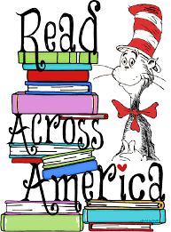
Read Across America
Tuesday, March 2nd

Read Across America is an annual reading motivation and awareness program that calls for every child in every community to celebrate reading on March 2, Dr. Seuss’s birthday.

Motivating children to read is an important factor in student achievement and creating lifelong successful readers. Research has shown that children who are motivated to read and spend more time reading do better in school.
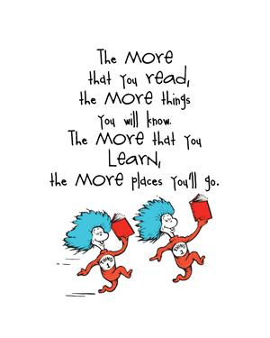
Helping your children enjoy reading is one of the most important things you can do as a parent, and it’s worth the investment of your time and energy. Children will learn reading skills in school, and often they come to associate reading with work, not pleasure. As a result, they lose their desire to read. It is that desire—the curiosity and interest—that is the cornerstone of benefitting from reading and reading related skills successfully.
By far the most effective way to encourage your children to love books and reading is to read aloud to them; the earlier you start, the better. Even a baby a few months old can see pictures and listen to your voice.
You can also encourage your children to love books by reading books yourself. They want to be just like you! They will soon mimic you and sit down with a book of their own, even if they can’t read yet.

Make reading together a special time to hold your kids and share the pleasure of a story without the distractions of screens. You may be surprised to find that a well-written children’s book is often as big a delight to you as it is to the little ones.

4
 | Family Time
Secret Letters
March Books
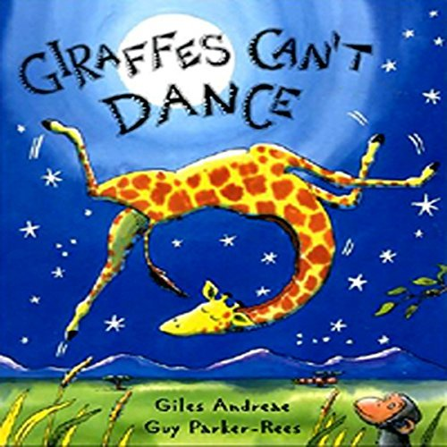
Giraffes Can’t Dance
By: Giles Andreae
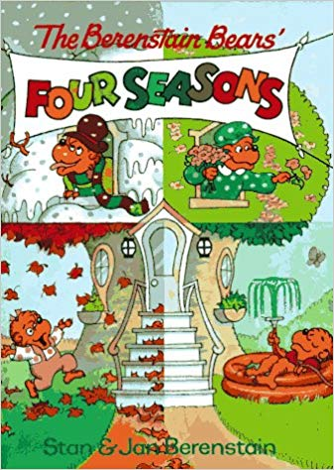
The Berenstain Bears’
Four Seasons
By: Stan & Jan Berenstain
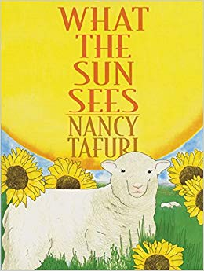
What the Sun Sees
By: Nancy Tafuri



Directions

Using the white crayon, write a variety of letters on white paper.

To prep the watercolor paints: fill a small cup with water, dip the paint brush into the water, and swirl the wet paint brush in each of the colors. Rinse the paint brush between colors to avoid blending the colors together.

Let your child paint over the letters. The wax of the crayon will resist the paint to magically reveal letters.

Tips

Make sure the paints are not too watered down. The more paint on the brush the better the letter reveal.

Print the letters firmly to ensure there is enough wax to resist the paint.

Extensions

Not ready for letters? Draw shapes, pictures, squiggles – it is all about the magic reveal!

Hide words, phrases, sentences, or write a secret message.

Activity From: https://busytoddler.com/2016/09/secret-letters-activity/

Supplies

White Paper

White Crayon

Watercolor Paints

Paint Brush

A Cup of Water

5

