HAPPY HOLIDAYS
December 2019
Sunday | Monday | Tuesday | Wednesday | Thursday | Friday | Saturday
 | Tumblin Tots Mondays |  |  |  | Soccer Shot Friday
 |  |  | 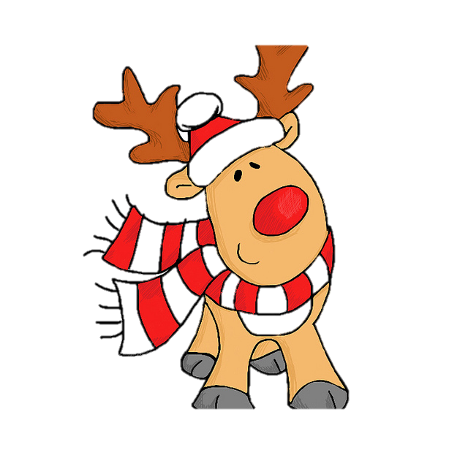
1 | 2 | 3 | 4 | 5 | 6 | 7
Happy Birthday  Peter  Ezra | Winter Door Contest  Starts | Spanish Classes  (Every Tuesday) | Happy Birthday  Iliana | Make a card day! | Open House | Breakfast with Santa!  10 am-12  Open house
 | 8 | 10 | 11  Make a Christmas Wish List | 12 | 13  Hot Cocoa & Cookies Day | 14
15 | 16 | 17 | 18 | 19 | 20 | 21
 | Happy Birthday  Teddy  Door Winners Announced!  This Photo by Unknown Author is licensed under CC BY-NC-SA |  | 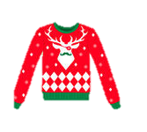  Ugly Sweater  Day | Roving Staff Meeting  11-2pm | Happy Birthday  Michael  Open House
22  This Photo by Unknown Author is licensed under CC BY-NC-ND | 23 Pajama Day | 24 | 25 | 26 | 27 | 28
Happy Birthday  Henri  Carver  (Dec. 23rd) | (School Wide)  SCHOOL CLOSED AT 2:45PM |  |  | Happy Birthday  Emily! | This Photo by Unknown Author is licensed under CC BY-SA | School Closed These Days
29 | 30 | 31  SCHOOL CLOSED AT 2:45PM | This Photo by Unknown Author is licensed under CC BY-NC-ND

